MONTGOMERY BOROUGH EMERGENCY MANAGEMENT
NEWSLETTER

The weather is breaking and the COVID epidemic has officially been declared over!
The Montgomery EMA has had the fortunate luck at purchasing a new truck to replace the old Utility 6-30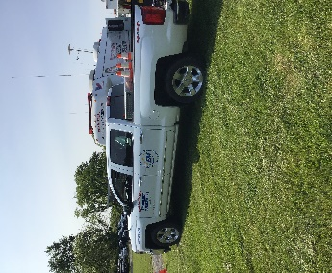We like to thank the many organizations/businesses who have donated towards this endeavor. White Horse Graphics did an outstanding job on the graphics, next will be installation of a PA system and lights.

On Thursday, May 18th, members of the EMA returned (after a 3 year COVID interruption) to the Allenwood Federal Prison Complex for “Emergency Preparedness Day”. An event that was open to the public. On display representing the EMA was the Command Post Unit, Water truck Utility 30 w/rubber boat and Utility 6-30. We were blessed with a beautiful day, great people who stopped and toured our Command Post. EMA Dale Brendle had his amateur radio set up trying to make contacts.

Montgomery Borough and TK Tackle are sponsoring a Riverfest the weekend of June 16-17. Its hard to believe that its been 51 years ago that Hurricane Agnes crested at 37.45 feet. Deputy EMA Coordinator Dennis Gruver will assist in showing “The Last Raft” and “Hurricane Agnes of ’72 flood”, on Friday evening on June 16th.

EMA Coordinator Greg Gruver and EMA member Dale Brendle attended the Task Force seminar training. Topics included school shootings and mass casualty situations. An advanced radar training session (by zoom) is being offered on the National weather service website on May 25th at 6 p.m.

We thank our volunteers who continue their training.

Next Montgomery EMA meeting will be Thursday, June 8th at 7 p.m. Meetings held at the EMA meeting room on Thomas Avenue, located behind the EMA garage. Volunteers are needed in different areas, come to a meeting and see how you can assist. Light Refreshments will be supplied.

Submitted by

Fae L. Herb
Administrative Assistant

